Computer Systems and Internet Technologies - COMP1589

Cascading Style Sheets (CSS)
Lab

SUMMARY
In this lab you will build upon last week to learn how to efficiently style your webpage using CSS, we will expand upon our use of the developer tools in the browser
For all labs I’d recommend you use Visual Studio Code and Google Chrome.

OBJECTIVES
- To become familiar with styling web pages using CSS.
- To demonstrate a basic understanding of CSS selectors and specificity
- To understand how to manipulate styling using the browser devtools

TASK
In this task you will be applying styling to a basic HTML page using three different techniques; inline, internal and external.
Once you’ve completed these steps then please take a look at the additional tasks.
Step 1
Create a new HTML file and open this in Visual Studio Code, then copy and paste the below HTML code ready for you to start styling.
<!DOCTYPE html>
<html lang="en-GB">
<head>
<!-- This is a comment, it's visible in the source but not on the page -->
<meta charset="utf-8">
<meta name="viewport" content="width=device-width, initial-scale=1">
<title>Hello World</title>
</head>
<body>
<h2>Responsive Social Login Form</h2>
<p>Resize the browser window to see the responsive effect. When the screen is less than 650px wide, make the two columns stack on top of each other instead of next to each other.</p>
<div class="container">
<form action="/action_page.php">
<div class="row">
<h2 style="text-align:center">Login with Social Media or Manually</h2>
<div class="vl">
<span class="vl-innertext">or</span>
</div>
<div class="col">
<a href="#" class="fb btn">
<i class="fa fa-facebook fa-fw"></i> Login with Facebook
</a>
<a href="#" class="twitter btn">
<i class="fa fa-twitter fa-fw"></i> Login with Twitter
</a>
<a href="#" class="google btn"><i class="fa fa-google fa-fw">
</i> Login with Google+
</a>
</div>
<div class="col">
<div class="hide-md-lg">
<p>Or sign in manually:</p>
</div>
<input type="text" name="username" placeholder="Username" required>
<input type="password" name="password" placeholder="Password" required>
<input type="submit" value="Login">
</div>
</div>
</form>
</div>
<div class="bottom-container">
<div class="row">
<div class="col">
<a href="#" style="color:white" class="btn">Sign up</a>
</div>
<div class="col">
<a href="#" style="color:white" class="btn">Forgot password?</a>
</div>
</div>
</div>
</body>
</html>

It should look something like the below when you open it in your browser. Not very nice!
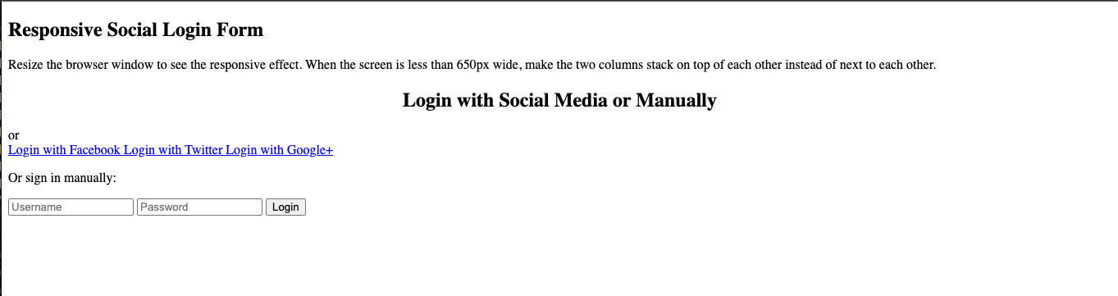
Step 2
Before we start styling our page, spend 5-10 minutes getting familiar with the code elements such as the “div” element we use as a wrapper, or the form and input elements for capturing user input.
You can learn more about these, and other HTML elements, from the Mozilla guide HTML: HyperText Markup Language | MDN.
Also I’d strongly recommend taking a look at the page with developer tools, let’s try that now. Right click on the title and click inspect.
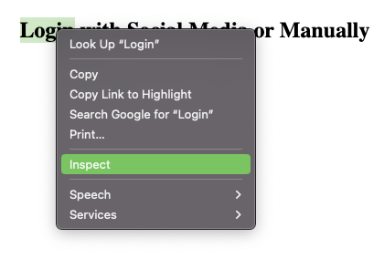
This will present an element inspector that shows you all the elements on the page, after the DOM has been created. This is a usual tool to understand not only the structure of the page but also how elements display “naturally”.
You can see in the screenshot below that if i hover over the “input” for the password in the element selector it shows me it’s width and how it is displayed/aligned, additionally in the right hand side I see the default browser (known as user agent) styles.
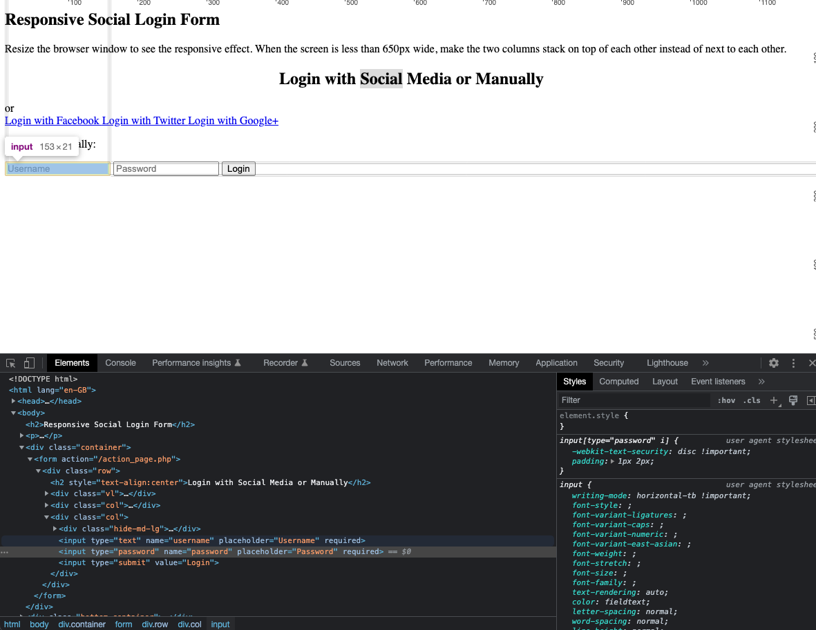

Step 3
Let’s start styling our form, we want it to look similar to this at the end.
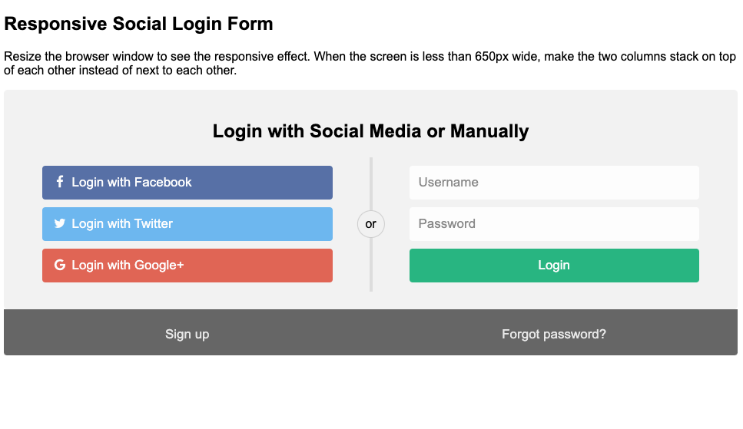You may have noticed that I’ve already added all the classes to the code for you that we will use in this example, usually you’d have to write these yourself.
Let’s start by adding our internal CSS. In between your “head” tags add a new tag called “style”, like below:
<head>
<style>
/* We'll add your CSS here - this is a comment in CSS */
</style>
</head>
Then let’s set our font family to something a bit nicer than the browser default, this will also help ensure that it displays the same across different browsers and devices.
<style>
body {
font-family: Arial, Helvetica, sans-serif;
}
</style>
If you refresh your browser you should notice a shift to a slightly nicer font, if you’re feeling adventurous then see if you can spot the font change in the devtools inspector.
*hint: it’s an inherited property, and often is easier to find under “computed”*
Now we’ll add our very basic, but important, reset. This wildcard selector ensures all of our elements use the same sizing system, this creates consistency when dealing with padding and borders.
<style>
body {
font-family: Arial, Helvetica, sans-serif;
}

* {
box-sizing: border-box;
}
</style>

Now we’ll style our main wrapper and input boxes, be sure to read the comments to understand what it is doing.
Due to the amount of code you’ll need to copy this from https://pastebin.com/XRuwWpcW
You should look something like this when you’re done, be sure not to just copy and paste without reading and playing around with the code.
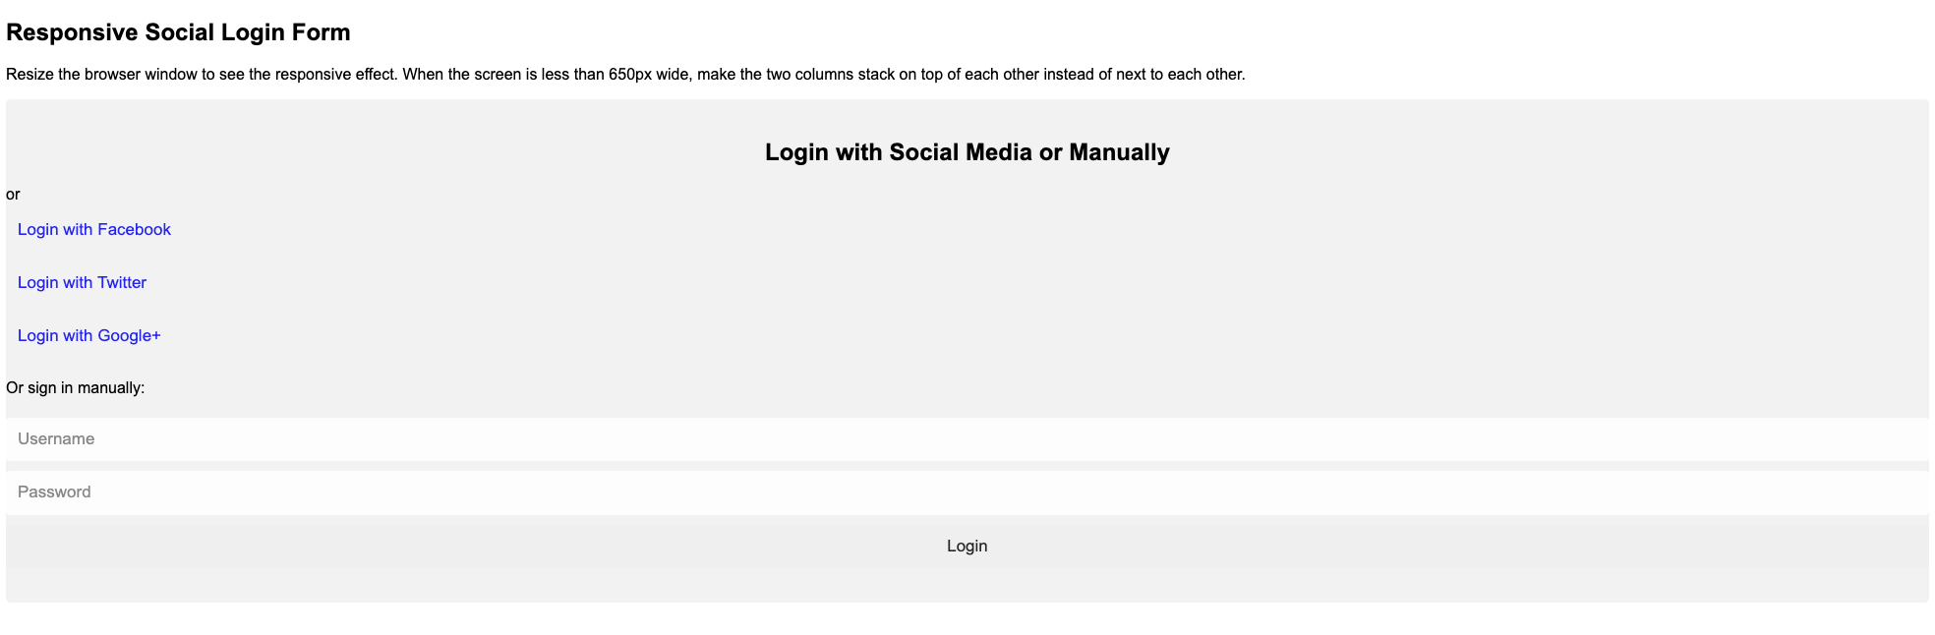
Try these challenges if you have time:
- Change the background colour to a different colour (if it’s dark, then make sure you change your font colour too!)
- Play around with a larger and smaller font size, see how much of a difference a few pixels can make
- Create your own hover effect, maybe use a background colour or have a play with the powerful CSS transform tool using scale() - CSS: Cascading Style Sheets | MDN
Step 4
It’s looking better but we still need to get to our two columns and colour in our buttons.
Give it a go colouring your buttons, if you get stuck then you can use the code below the image…
Your goal is to get them looking like below. To help you out the colours used are:
Facebook: #3B5998, Twitter: #55ACEE, Google: #dd4b39, Login: #04AA6D. Don’t forget to add hover states where needed.
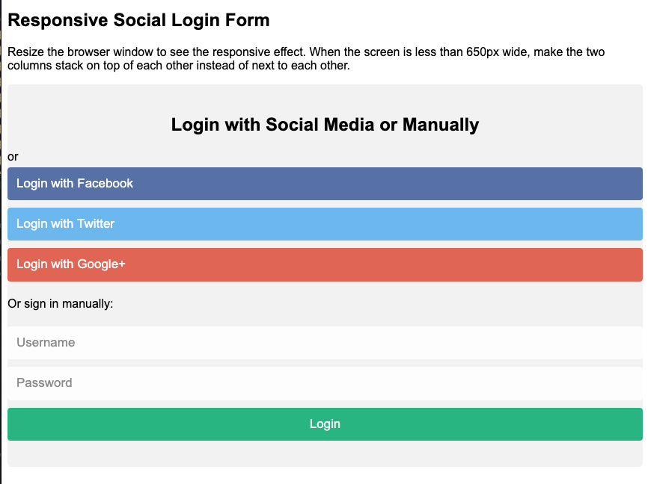

/* add appropriate colors to fb, twitter and google buttons */
.fb {
background-color: #3B5998;
color: white;
}
.twitter {
background-color: #55ACEE;
color: white;
}
.google {
background-color: #dd4b39;
color: white;
}
/* style the submit button */
input[type=submit] {
background-color: #04AA6D;
color: white;
cursor: pointer;
}
input[type=submit]:hover {
background-color: #45a049;
}

Now let’s add our two column layout, this is slightly more complex so make sure you read the comments and play around with it - get the code at https://pastebin.com/ixyAuPdh

You should now look like this:
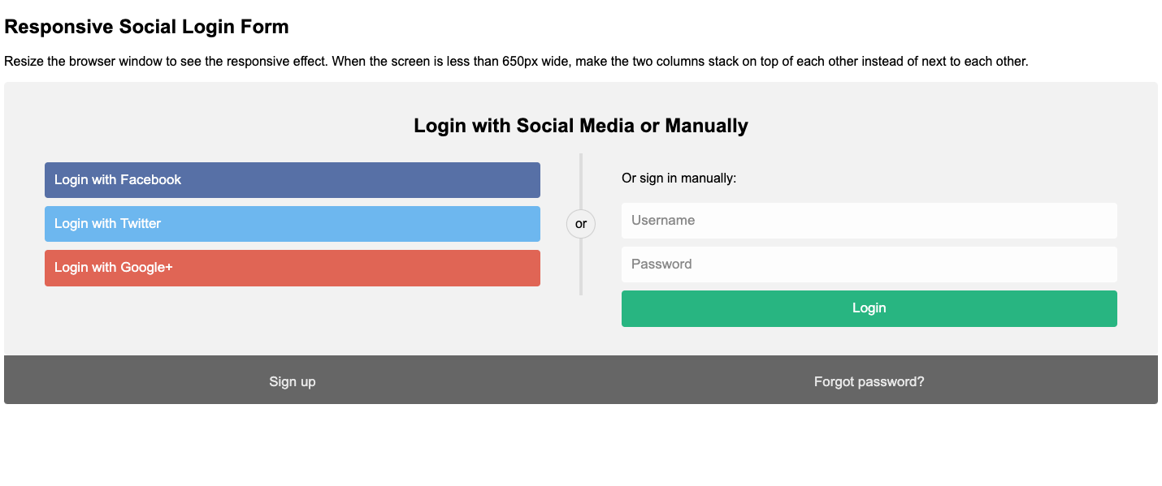
Step 5
The eagle eyed amongst you may have noticed that we have missed one class that is used in the code, this is because I want you to make this responsive - you’ll need to use Media Queries to conditionally apply/remove CSS styling.
To test how this looks on smaller devices, in devtools, click the phone/tablet icon at the top left
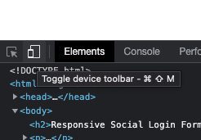
You’ll then be able to preview your website on different devices and screen sizes, very important when developing and testing websites.
Give it a go at adding media queries and styling to make this into a one-column layout on small devices. If you get stuck then you can find the code below but be sure to read through, play with it and try to understand it fully.
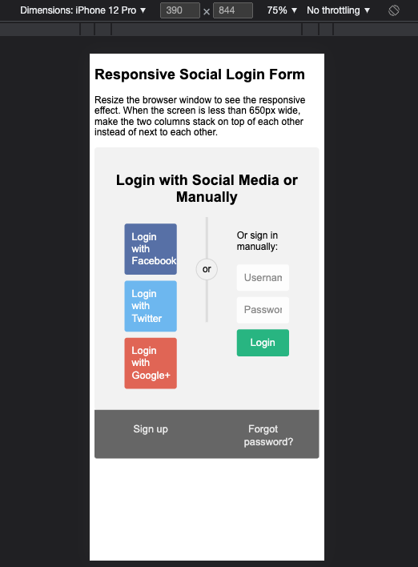

/* hide some text on medium and large screens */
.hide-md-lg {
display: none;
}
/* Responsive layout - when the screen is less than 650px wide, make the two columns stack on top of each other instead of next to each other */
@media screen and (max-width: 650px) {
.col {
width: 100%;
margin-top: 0;
}
/* hide the vertical line */
.vl {
display: none;
}
/* show the hidden text on small screens */
.hide-md-lg {
display: block;
text-align: center;
}
}
The end result we would expect to see is something similar to below, if not take a look at the code and see if you can work out why.
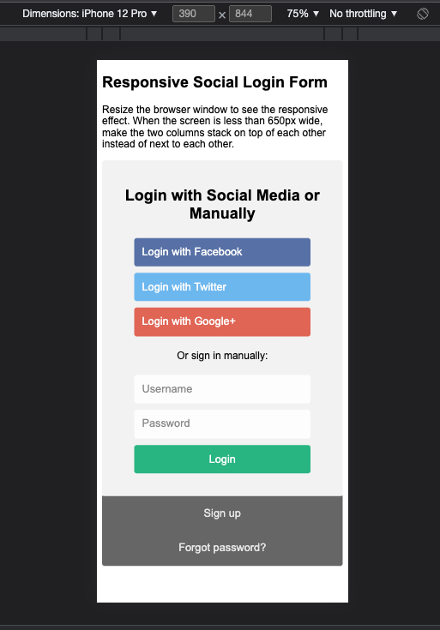

Step 6
So far we have looked at using internal CSS only, this is a “style” tag in the head of the document. This is great for quickly prototyping but when we have hundreds or thousands of lines of code it becomes unmanageable.
This is where external CSS comes into play, try copying all your code between the style tags into a new file called “main.css”.
Save that file and delete the style tag from your HTML document, and replace it with the below… This allows you to split your styling and your structure in a very tidy way - as well as do a lot more complex things to speed up your website.
<link rel="stylesheet" href="./main.css">
In addition to external and internal CSS there is also inline, it’s very uncommon to ever “need” to use these but there are cases where your only option is inline styling. This approach is limited as we can’t use certain CSS features such as pseudo tags.
Give it a go by changing the font size of your “p” tag near the top of your page.
<p style="font-size: 23px;">Resize the browser window to see the responsive effect. When the screen is less than 650px wide, make the two columns stack on top of each other instead of next to each other.</p>
You may have noticed that we are missing icons for the social networks but have tags there for them, you can give it a go at applying your own icons for those tags however they are actually common tags for a library known as FontAwesome.
Drop this in the head of your document to see the tags appear:
<link rel="stylesheet" href="https://cdnjs.cloudflare.com/ajax/libs/font-awesome/4.7.0/css/font-awesome.min.css">

EXTRA
If you’ve completed all the steps above then spend some time experimenting with CSS further or getting to know the developer tools in your preferred browser.
See if you can achieve the following:
- Changing elements styling using devtools only - see if you can change the background colour on the container in devtools only (View and change CSS - Chrome Developers)
- Add in media query for dark mode - see if you can add in a dark mode version of your login form (prefers-color-scheme - CSS: Cascading Style Sheets | MDN)
- See if you can make the transition effects smoother for the button hover states (Using CSS transitions - CSS: Cascading Style Sheets | MDN)
- Try changing the two-column layout from using “float” to grid(CSS Grid Layout - CSS: Cascading Style Sheets | MDN) or flexbox(flex - CSS: Cascading Style Sheets | MDN)
CSS Reference
CSS: Cascading Style Sheets | MDN
CSS Cheat Sheet
CSS features reference - Chrome Developers

